SPACE OCCUPYING LESIONS (SOL)
Introduction
There are many different types of mass lesion in the head. In developing countries, tuberculoma is a very common cause, but in developed countries cerebral neoplasms are the most frequent. The clinical features relate to the site of the mass, its nature and its rate of expansion. Symptoms and signs are produced by a number of mechanisms but commonly due to pressure on the functional part of the brain. Management will depend on the cause of space occupying lesion.
Definition
This is any mass lesion within the intracranium.
Causes
1. Infections
- Cerebral abscess (could be pyogenic, Toxoplasma)
- Tuberculoma - Intracranial granulomas caused by caseating Tubercobacili.
- Cysticercosis - caused by Teania solium
- Echinococcosis (hydatid cysts)
- Schistosomiasis
2. Trauma
- Subdural haematoma
- Extradural haematoma
3. Vascular
- Intracerebral haematoma
4. Inflammatory
- Sarcoid mass
5. Neoplastic
- Cerebral neoplasm (benign and malignant)
6. Others
- Embryonic dysplastic lesions (craniopharyngioma, hamartoma)
- Arachnoid cyst
- Colloid cyst (in the ventricles)

1. Brain Abscess

Definition: It is a suppurative infective condition involving the brain substance.

Sources of infection
A. Direct spread of infection from
- Compound fracture of the skull
- Meningitis
- Chronic middle ear disease e.g. Chronic Otitis Media
- Infection of paranasal sinus e.g. sinusitis
- Mastoiditis
B. Haematogenous spread from distant foci
- Heart e.g. Infective endocarditis
- Chest infection e.g. Lung abscess
- Osteomyelitis

Causative microbes
- Streptococcal
- Staphylococci
- Escherichia coli
- Klebsiela

Clinical features
1. Headache- Localized to the affected site or generalized
2. Fever
3. General malaise
4. Signs of Increased intracranial pressure. These signs include;
i. Nausea and vomiting (Projectile vomiting) - May compress the emetic centre
ii. Bradycardia
iii. Confusion
iv. Drowsiness
v. Stupor
vi. Papilloedema - Swelling of the optic disc.
5. Cranial nerve palsies
-Mass may compress a cranial nerve
6. Focal Neurological signs
- Depends on where the lesion is e.g. there could be;
  - Hemiplegia
  - Convulsions
  - Aphasia
  - Ataxia and Nystagmus – if the cerebellum is involved.
Note
- Nystigmus is disturbance of ocular movements characterized by rhythmical oscillation of the eye involuntary.
- Ataxia is lack of coordination in any movement

Diagnosis / Investigations
- Good History
- Good central nervous system Examination
- Blood for full Haemogramme and ESR - White blood cells will be raised in case of an infection.
- Skull X-Ray – may be normal or show evidence of bone erosion in patients with mastoiditis or sinusitis.
- EEG - may show focal abnormalities
- CT-scan- Confirms diagnosis
- Arteriogram

Treatment
1. IV broad spectrum antibiotics.
-The antibiotics should be active against both gram positive and gram negative organisms.
2. Dexamethasone - To reduce Oedema
3. Surgical Drainage. Drainage of pus or birr holes for haematoma.
4. Treat the primary cause.

Prognosis
Prognosis is poor - 80% mortality.
-comes about often due to misdiagnosis.
-epilepsy is common among survivors.

2. Common Brain Tumours
Tumours are common causes of space occupying lesions. These tumours include;
1. Metastatic tumours. Account for 50% of the cases. Areas of metastasis include; Bronchus, breast, stomach, prostate, thyroid and kidney.
2. Primary malignant tumours of neuroepithelial tissues , account for 35% of the cases. Examples are; Astrocytoma, oligodendroglioma, mixed (oligoastrocytomas) gliomas, ependymoma, primary cerebral lymphoma, and medulloblastoma.
3. Benign tumours. Account for 15% of the cases. Examples include; Meningioma and neurofibroma.

NOTE
- Primary intracranial tumours account for some 10% of neoplasms.
- Metastases are the commonest intracranial tumours.
- Symptomless meningiomas are also found regularly on imaging or at autopsy.

Gliomas
- These malignant tumours of neuroepithelial origin are usually seen within the hemispheres, but occasionally in the cerebellum, brainstem or cord.
- The cause of gliomas are largely unknown.
- Glioma is occasionally associated with neurofibromatosis.
- They tend to spread by direct extension, virtually never metastasizing outside the CNS.
Astrocytomas
- These gliomas arise from astrocytes.
- They are classified histologically into grades I-IV.
- Grade I astrocytomas grow slowly over many years, while grade IV tumours (glioblastoma) cause death within several months.
- Cystic astrocytomas of childhood are relatively benign, and usually cerebellar.

Oligodendrogliomas
- These arise from oligodendrocytes.
- They grow slowly, usually over several decades.
- Calcification is common.

Meningiomas
- These benign tumours arise from the arachnoid membrane and may grow to a large size, usually over years.
- Those close to the skull erode bone.
- They often occur along the intracranial venous sinuses, which they may invade.
- They are rare below the tentorium.
- Common sites are the parasagittal region, sphenoidal ridge, subfrontal region, pituitary fossa and skull base.
Neurofibromas (Schwannomas) - These solid benign tumours arise from Schwann cells and occur principally in the cerebellopontine angle, where they arise from the eighth nerve sheath.

Other neoplasms
Other less common neoplasms include cerebellar haemangioblastoma, ependymoma of the fourth ventricle, colloid cyst of the third ventricle, pinealoma, chordoma of the skull base, glomus tumour (of the jugular bulb), medulloblastoma (a cerebellar childhood tumour), craniopharyngioma and cerebral lymphoma. Also pituitary tumours are known to cause space occupying lesions.
Clinical features
Mass lesions within the brain produce symptoms and signs by three mechanisms:
- By direct effect - brain is either destroyed locally or function is impaired
- By secondary effects of raised intracranial pressure and shift of intracranial contents (e.g. papilloedema, vomiting, headache)
- By provoking either generalized or partial seizures.
Although neoplasms, either secondary or primary, are the common mass lesions in the brain, cerebral abscess, tuberculoma, subdural and intracranial haematoma can also produce features that are clinically indistinguishable.
Direct effects of mass lesions
The hallmark of a direct effect of a mass is local progressive deterioration of function. Tumours can occur anywhere within the brain. Three examples are given:
- A left frontal meningioma caused a frontal lobe syndrome over several years - vague disturbance of personality, apathy and impaired intellect. Expressive aphasia developed, followed by progressive right hemiparesis as the corticospinal pathways became involved. As the mass enlarged further, pressure headaches and papilloedema developed.
- A right parietal lobe glioma caused a left homonymous field defect (optic radiation). Cortical sensory loss in the left limbs and left hemiparesis followed over 3 months. Partial seizures (episodes of tingling of the left limbs) developed.
- A left eighth nerve sheath neurofibroma (an acoustic neuroma, Schwannoma) in the cerebellopontine angle caused, over 3 years, progressive perceptive deafness (VIII), vertigo (VIII), left facial numbness (V) and weakness (VII), followed by cerebellar ataxia on the same side. Papilloedema was a late sequel.
Raised pressure and shift of intracranial contents
Raised intracranial pressure causing headache, vomiting and papilloedema is a relatively unusual presentation of a mass lesion.
These symptoms often imply hydrocephalus - obstruction to CSF pathways.
Typically this is produced early by posterior fossa masses (that obstruct the aqueduct and fourth ventricle) but later with lesions above the tentorium.
Shift of the intracranial contents produces features that coexist with the direct effects of any expanding mass:
- Distortion of the upper brainstem, as midline structures are displaced either caudally or laterally by a hemisphere mass. This causes impairment of consciousness.
- Compression of the medulla, by herniation of the cerebellar tonsils caudally through the foramen magnum - an example of coning. This causes impaired consciousness, respiratory depression, bradycardia, decerebrate posturing and death.
- False localizing signs - This is said to be false only because they do not point directly to the site of the mass.

Three examples of false localizing signs are:
- A sixth nerve lesion, first on the side of a mass and later bilaterally - as the VI nerve is compressed during its long intracranial course.
- A third nerve lesion develops as the temporal lobe uncus herniates caudally, compressing the third nerve against the petroclinoid ligament. The first sign is ipsilateral pupil dilatation as parasympathetic fibres are compressed.
- Hemiparesis on the same side as a hemisphere tumour (i.e. the side you would not expect) produced by compression of the contralateral cerebral peduncle within the brainstem on the free edge of the tentorium.
These false localizing signs, though unusual, are of importance because they indicate that shift of brain has occurred.

Seizures
Partial seizures, simple or complex, that may evolve into generalized tonic-clonic seizures, are characteristic of many hemisphere masses, whether malignant or benign.
Investigations
- CT and MR imaging
- Imaging is mandatory when a tumour is suspected. It has its own limitations because not all the malignant and benign lesions have typical characteristic features. The appearances are not entirely reliable.
2. Technetium brain scan
- This is of value in diagnosis of destructive skull vault (e.g. metastases) and skull base lesions.
3. Skull films
- In hemisphere tumours, plain films have no value. With metastases, skull vault lesions may be seen; and with pituitary tumours, enlargement of the pituitary fossa.
4. Routine tests (Routine X-ray)
- Since metastases are common, routine tests, e.g. chest X-ray, should be performed.
5. More specialized neuroradiology
- MR angiography and MR spectroscopy are occasionally used to define changing size or blood supply.
- Positron emission tomography (PET) is helpful in grading gliomas or locating an occult primary lesion.
6. Lumbar puncture
- Lumbar puncture is contraindicated when there is increased intracranial pressure.
- Withdrawing CSF may provoke immediate herniation of the cerebellar tonsils.
- LP should be done only after imaging, but is rarely necessary.

7. Biopsy and tumour removal
- Stereotactic biopsy via a skull burr-hole for histology to rule out malignancy.
- Also open exploration (craniotomy) is usually performed in case of symptomatic meningioma

- Management
- Corticosteroids; i.v. or oral dexamethasone is given.
- Intravenous mannitol, an osmotic diuretic, is also used to reduce oedema.
- Epilepsy is treated with anticonvulsants.
- Surgical removal of a brain tumour is an objective, it is not always possible, nor is surgery always necessary.
- Follow-up with serial imaging is sometimes preferable.
- At surgical exploration, some benign tumours can be entirely removed (e.g. acoustic neuromas, some parasagittal meningiomas). With a brain malignancy it is rarely possible to remove an infiltrating mass instead Biopsy and debulking are achieved.
- Radiotherapy is usually given to gliomas and metastases, and improves survival.
- Chemotherapy - Vincristine, procarbazine and temozolamide are used. Temozolamide has an active metabolite that interrupts DNA replication by methylation of the 06 position of guanine.
NOTE
- Tumours within the posterior fossa require removal often because of raised pressure and the danger of coning.
- Overall mortality for posterior fossa exploration remains around 10%.
- An isolated posterior fossa metastasis can sometimes be excised successfully.

Prognosis
- Most malignant brain tumours continue to have a poor prognosis despite advances in imaging, surgery, chemotherapy and radiotherapy - less than 50% survival for high-grade gliomas at 2 years. The management involves multidisciplinary care.

3. TRAUMA WITH HAEMORRHAGE
Trauma with haemorrhage is a common cause of space occupying lesion. Clinical presentation will depend on site of haemorrhage and amount of blood lost.

The causes of bleeding include;
- Trauma- Head injury
- Rupture of cerebral blood vessels mainly seen in Hypertensive patients
- Bleeding disorders
- Rupture of aneurysms

Sites where bleeding may occur
- Intracranial region
- subarachnoid space – Subarachnoid haemorrhage
- Extradural space
- subdural space

Effects of bleeding; Blood collection in the brain accumulates and may form haematoma, which may compress the brain tissue underneath.

SUBDURAL HAEMATOMA/ HAEMORRHAGE
This occurs when blood accumulates in the subdural space commonly following head injury. Haemorrhage may result from rupture of veins in the subdural space. The haematoma formed causes compression of the brain tissues with herniation of the brain substance into foramen magnum leading to compression of the brain stem. This quickly interferes with vital centre leading to respiratory arrest and loss of control pulse and blood pressure in severe forms.

Clinical features
- History of recent head trauma, prior to onset of symptoms particularly in elderly patients
- Headache
- Slowness of thinking
- Seizures
- Confusion
- Drowsiness
- Later stupor and patients may go into coma.

On Examination
- Features of focal neurological impairments.
- Hemiplegia
- Aphasia
- Defective visual fields
- Cranial Nerve palsies
    - 3rd Cranial nerve palsy
    - Ptosis
    - Dilated pupils and not reacting to light
Diagnosis
1. Confirm using a CT scan, MRI
2. Arteriogram-shows displacement of cerebral arteries from the skull

Treatment
- If the patient has a small haematoma it resolves spontaneously.
- If the haematoma is large it will require surgical removal.

Patterns of sensory loss.
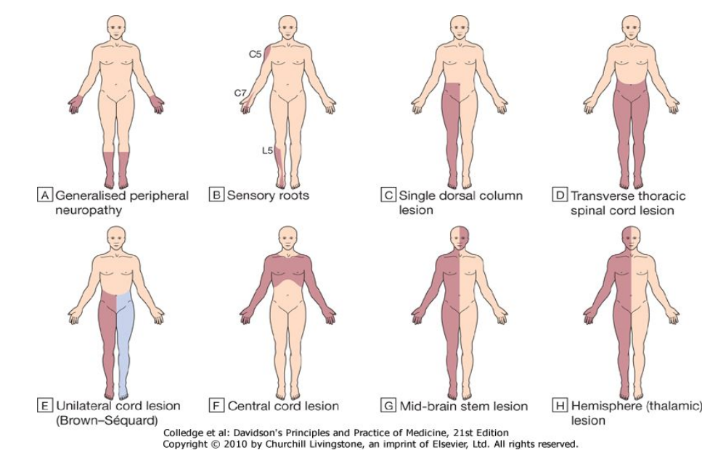
- Generalised peripheral neuropathy.
- Sensory roots.
- Single dorsal column lesion (proprioception and some touch loss).
- Transverse thoracic spinal cord lesion.
- Unilateral cord lesion (Brown-Séquard): ipsilateral dorsal column (and motor) deficit and contralateral spinothalamic deficit.
- Central cord lesion: 'cape' distribution of spinothalamic loss.
- Mid-brain stem lesion: ipsilateral facial sensory loss and contralateral loss on body below the vertex.
- Hemisphere (thalamic) lesion: contralateral loss on one side of face and body.
Summary
In this paper the various causes of space occupying lesion have been discussed. These include brain abscess, tumours, and trauma with haemorrhage. Space occupying lesions present with symptoms when it exerts pressure on the functional part of the brain. Management of space occupying lesions depend on the cause.

REFERENCES
Davidson's Principles and Practice of medicine - 21th Edition
Kumar and clark Textbook of clinical medicine - 6th Edition
Harrison's text book of Internal Medicine - 17th Edition
Current Medical Diagnosis and Treatment - 45th Edition
Kaplan Medical Usmle Step 2 Internal Medicine 2005-20006 Edition
Oxford Textbook of medicine.
http//www.merckmanuals.com/-/space occupying lesion.
http//www.mdeicinenet.com/-/article.htm.

